Staff Management Module

Introduction
The Staff Management module enables administrators to add and manage staff records within the system. This module helps maintain accurate staff information for operational and administrative purposes.
How to Add a New Staff Member

Step-by-Step Procedure
- Login to the system using Admin credentials.
- From the left navigation pane, click Users.
- Select Staff.

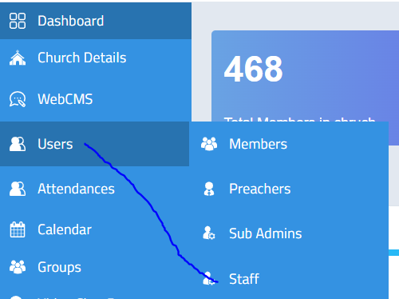
Adding a New Staff
- Click the Add New button.
- A new staff registration form will open.
- Enter all the required details in the form.
- Click Submit.

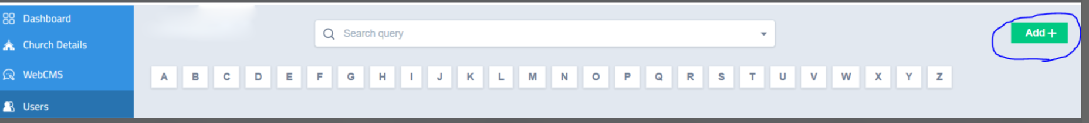
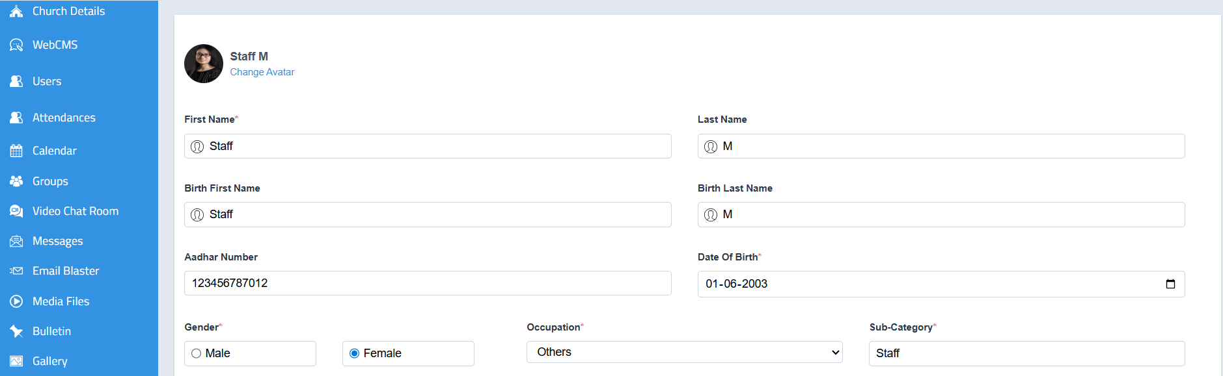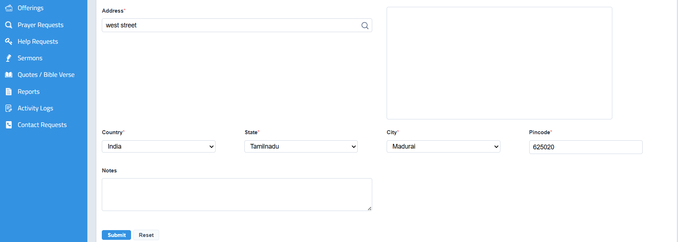
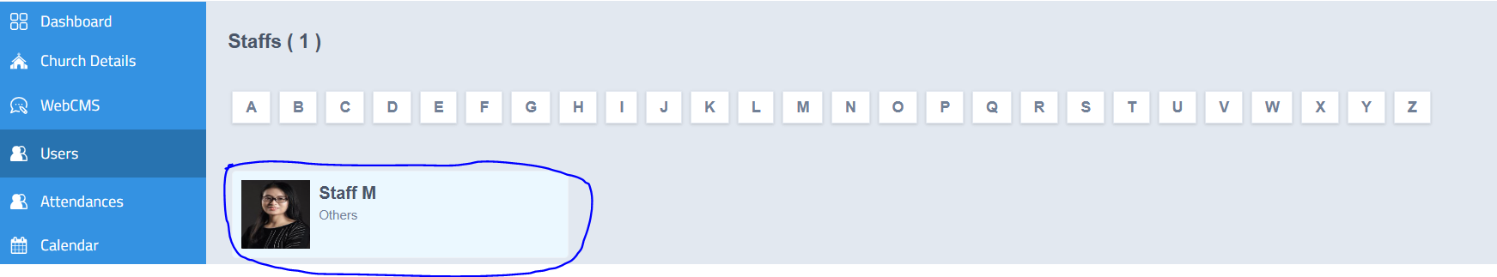

How to Access Member Profile Actions
- Login to the system using Admin or Staff credentials.
- Navigate to Users → Staff .
- Click the name and the profile will be opened
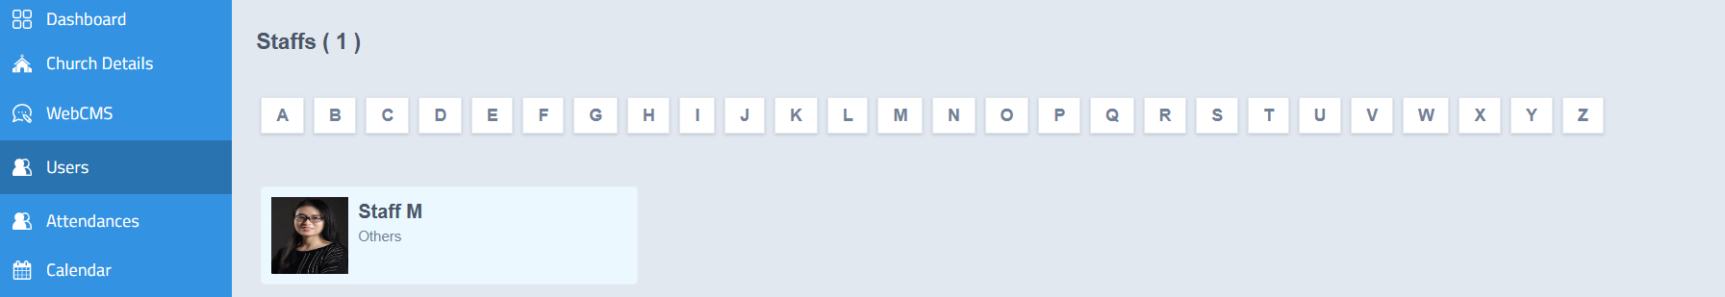

Staff Profile Sections
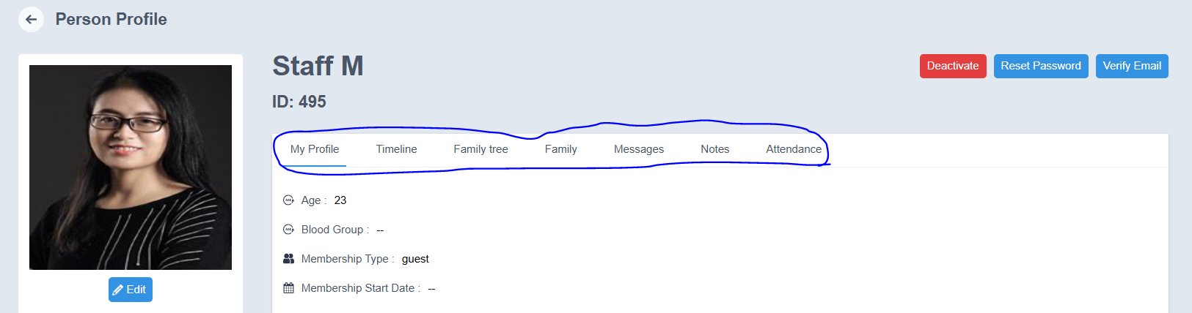
The following tabs and details can be viewed in the profile:
  - My Profile
  - Timeline
  - Family Tree
  - Family
  - Messages
  - Notes
  - Attendance

Profile
- Displays the complete profile information of the sub admin.
Includes personal details such as name, contact information, date of birth, and other registered

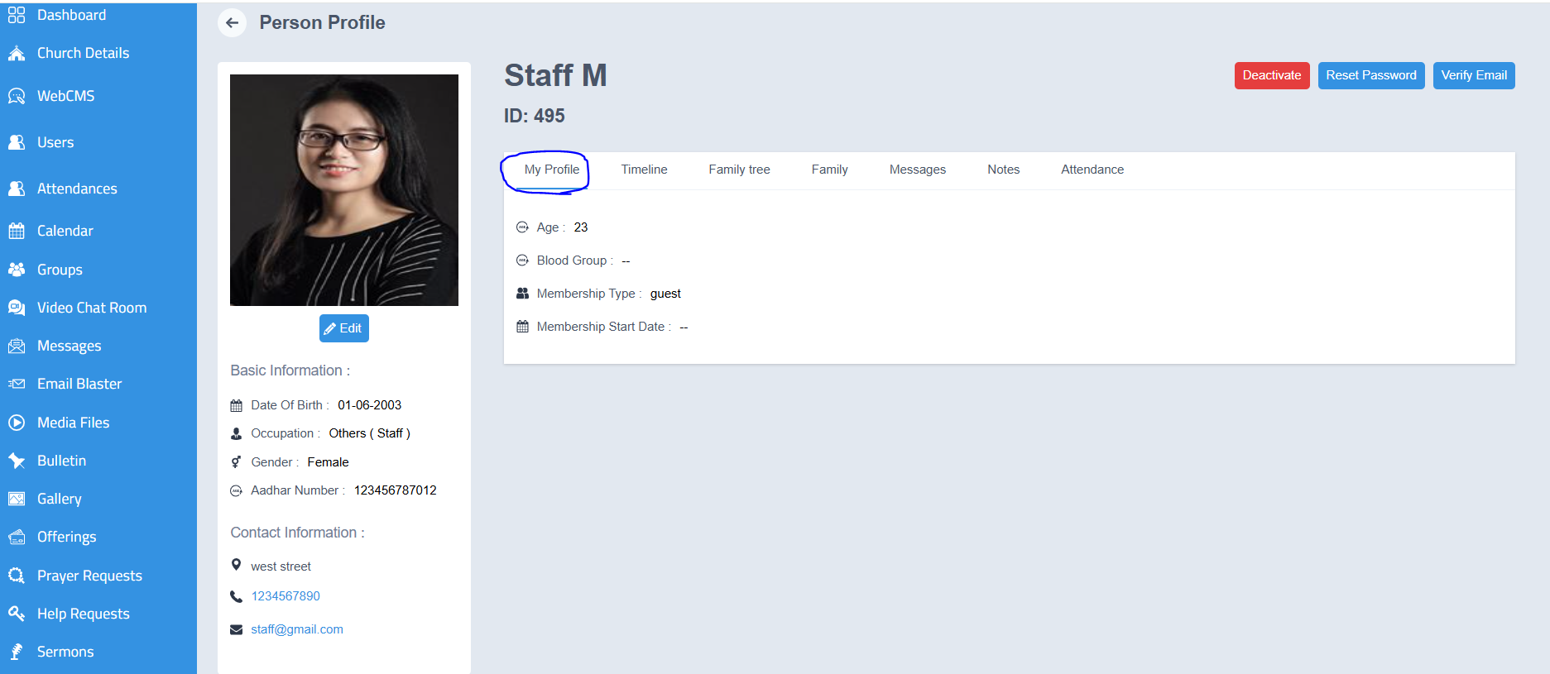

2. Timeline
- Displays the activity history of the member profile.
- All updates and actions performed in the profile can be viewed here.

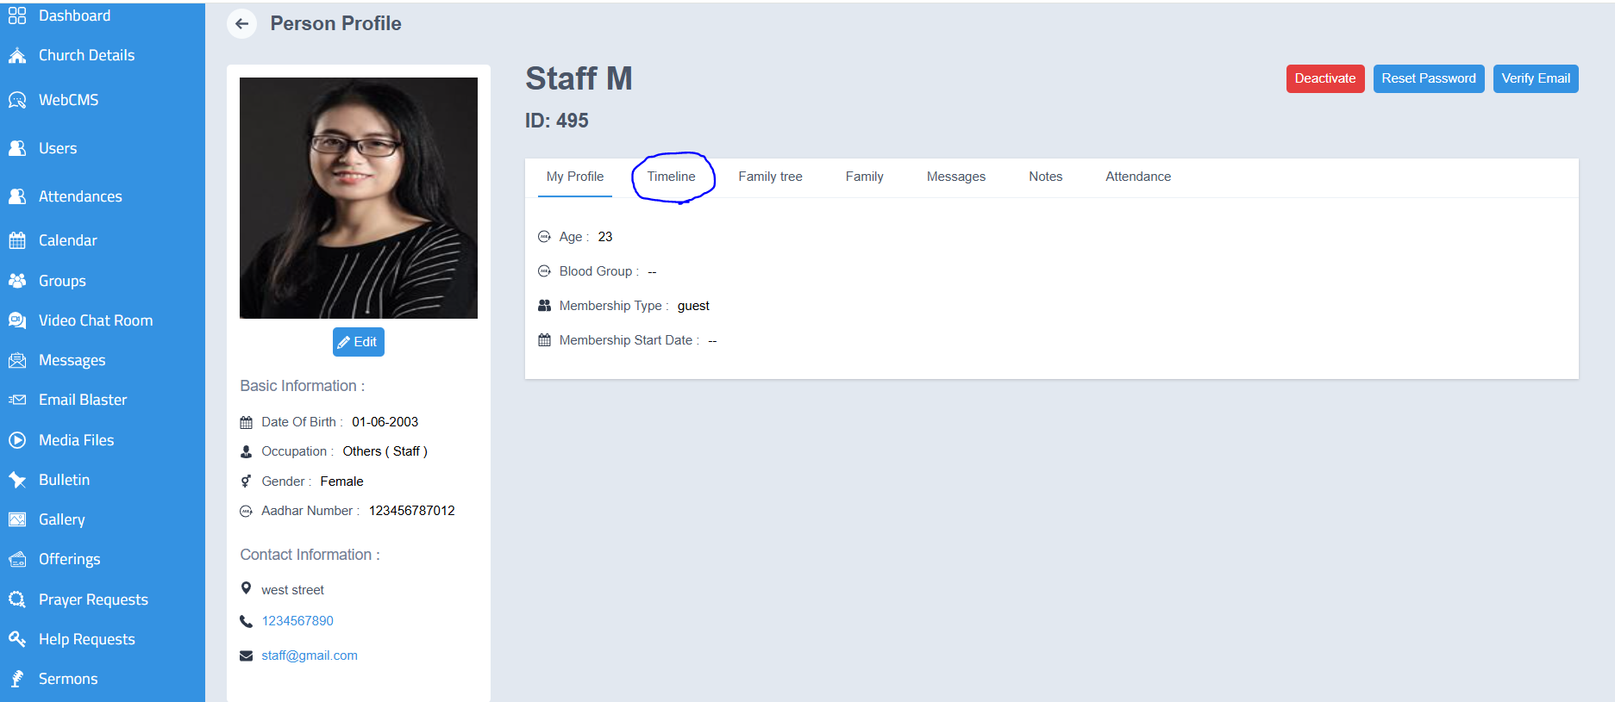
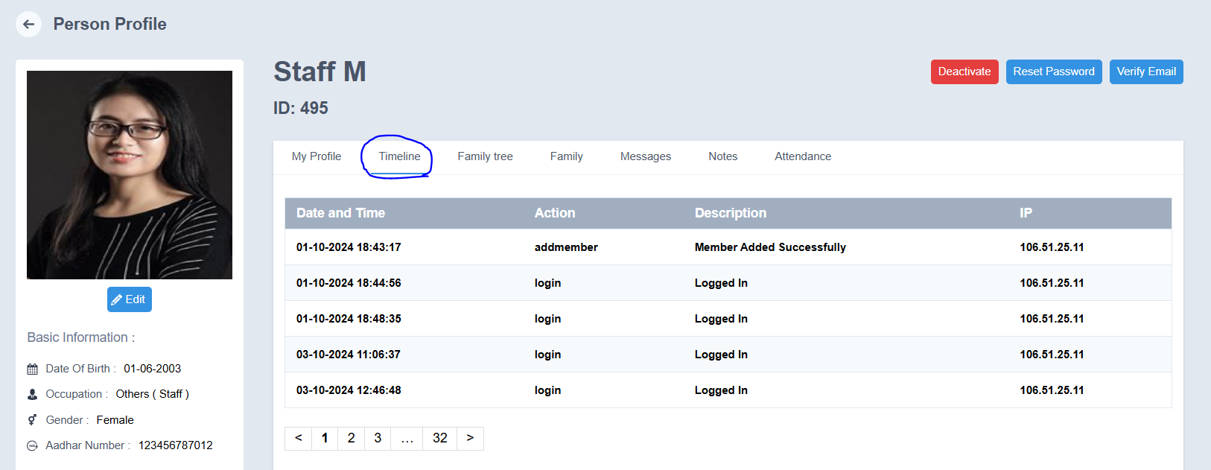

3. Family Tree
- Displays the family details linked to the member.
- Family information such as:
  - Name of the family member
  - Relationship
  - Date of Birth
  - Email ID
  - Other related details
can be viewed here.
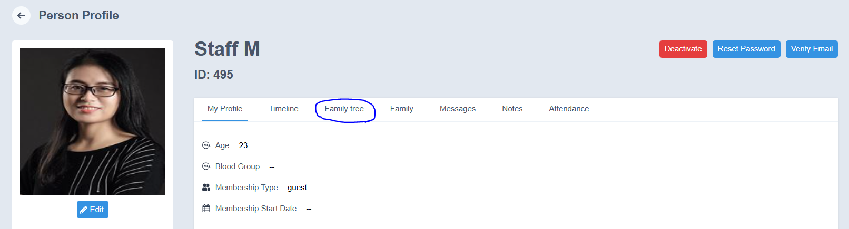
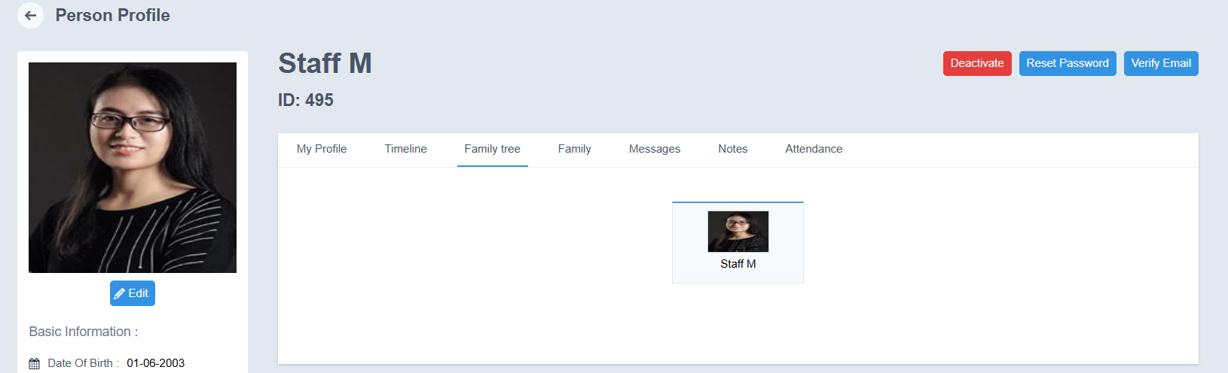

- Family
- Family tree details can be added while creating the member profile in the Users module.
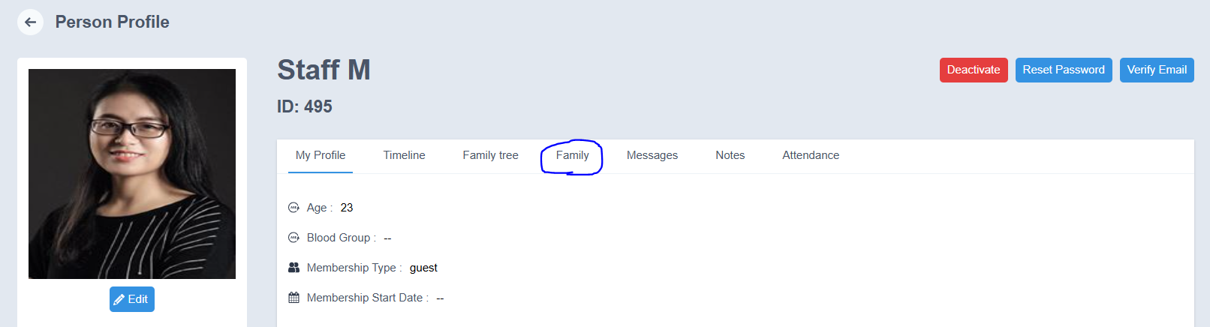
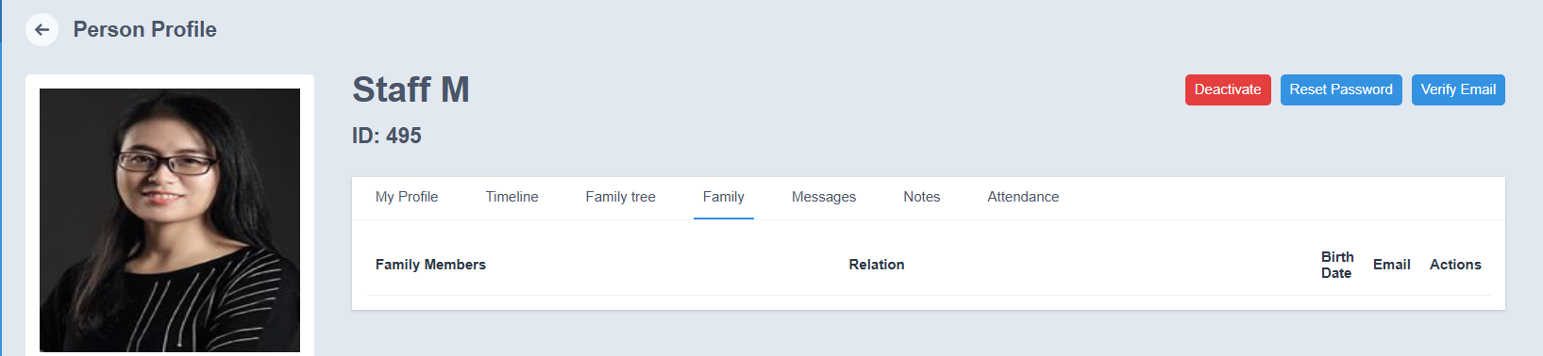

Messages
- Displays messages sent by the member.
- The following details can be viewed:
  - Status
  - Subject
  - Message
  - Attachments
  - Sent On
  - Action

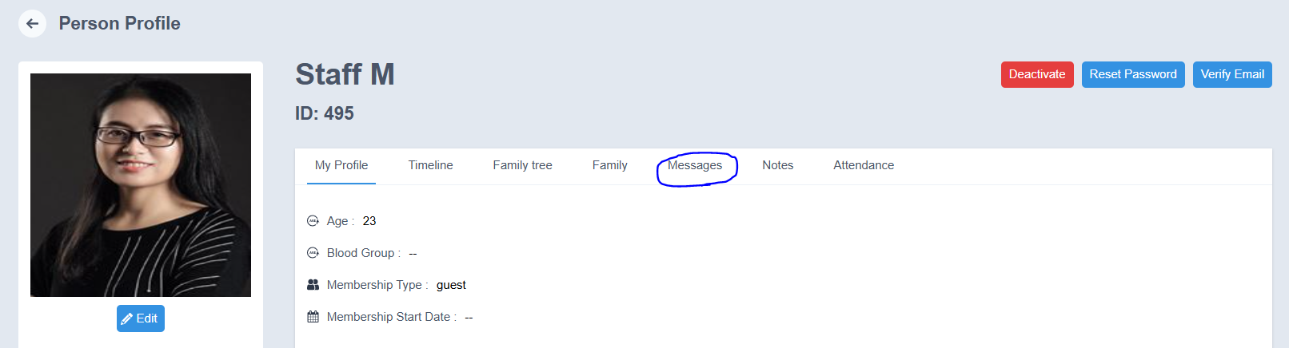
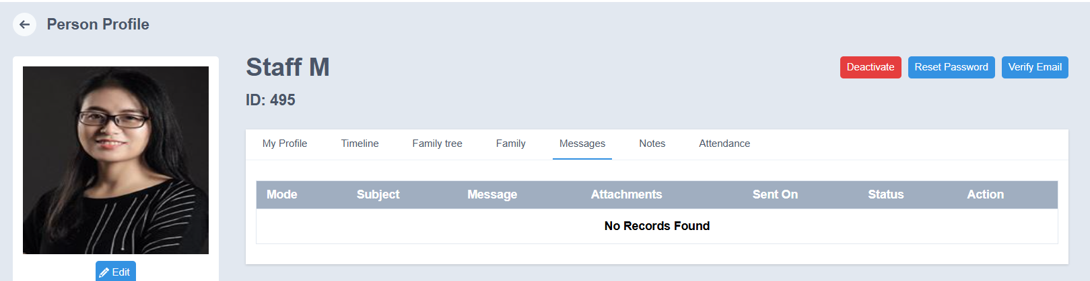

6. Notes
- Admin can add notes related to the member.
- Enter the note in the provided field.
- Click Submit to save the note.
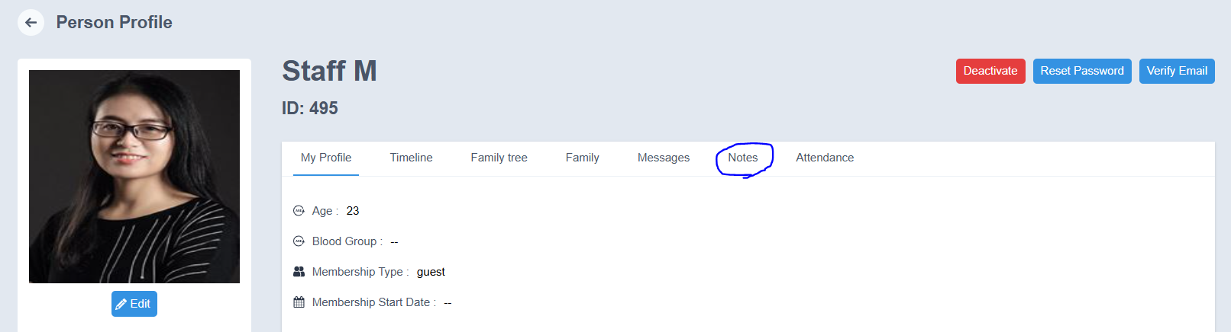

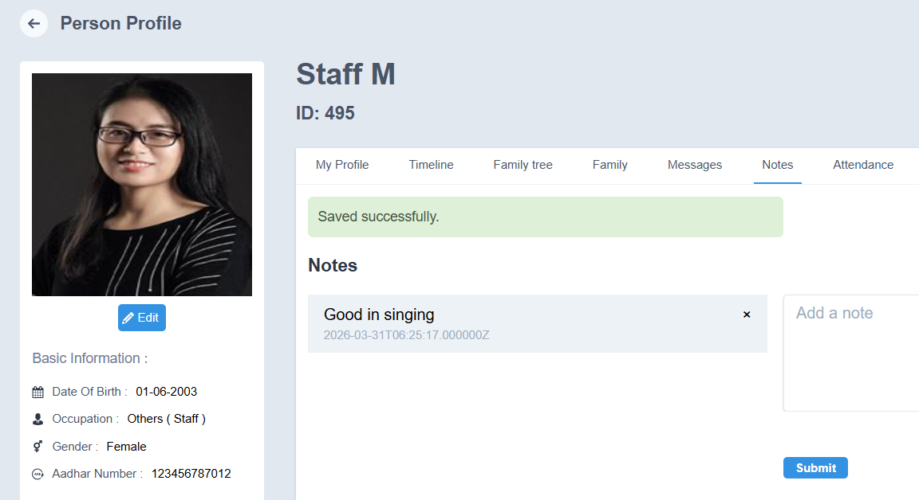

7. Attendance
- The attendance details of the member can be viewed in this section.
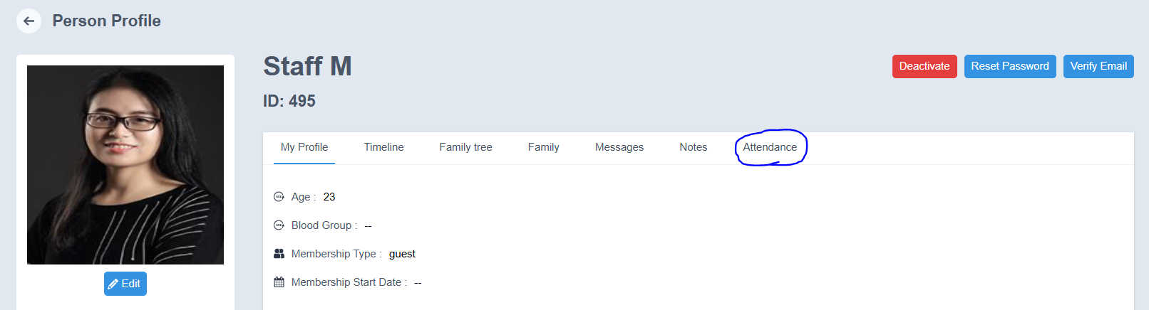
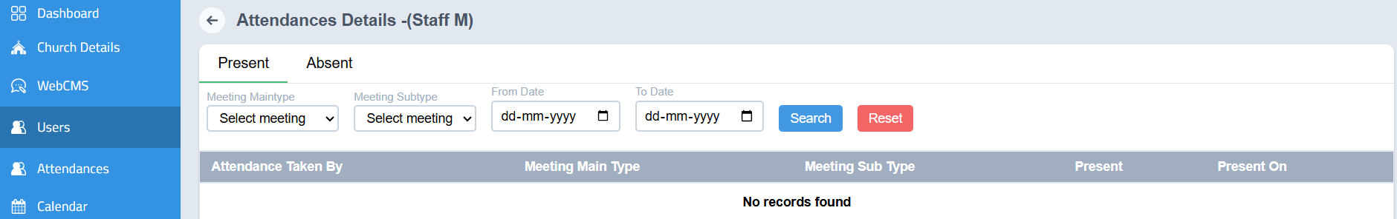

Available Member Profile Actions

Edit Member Profile
- Open the required member profile.
- Click the Edit option.
- Make the necessary changes.
- Click Submit to save the updated details.
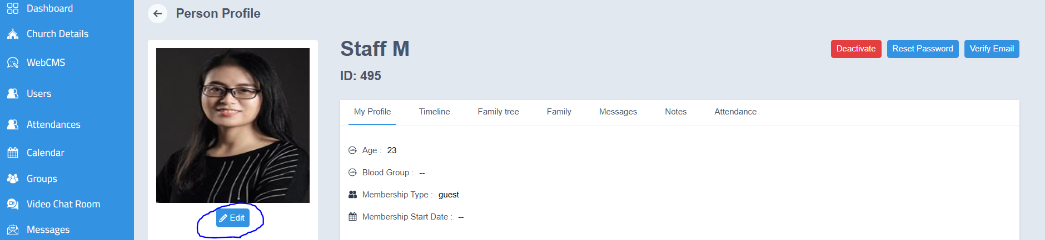
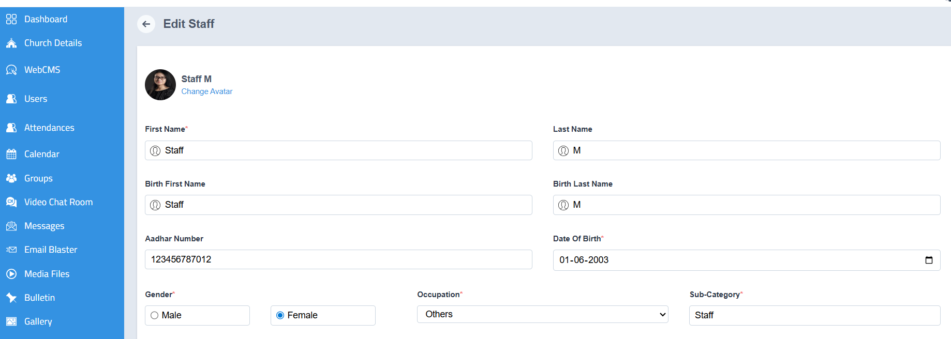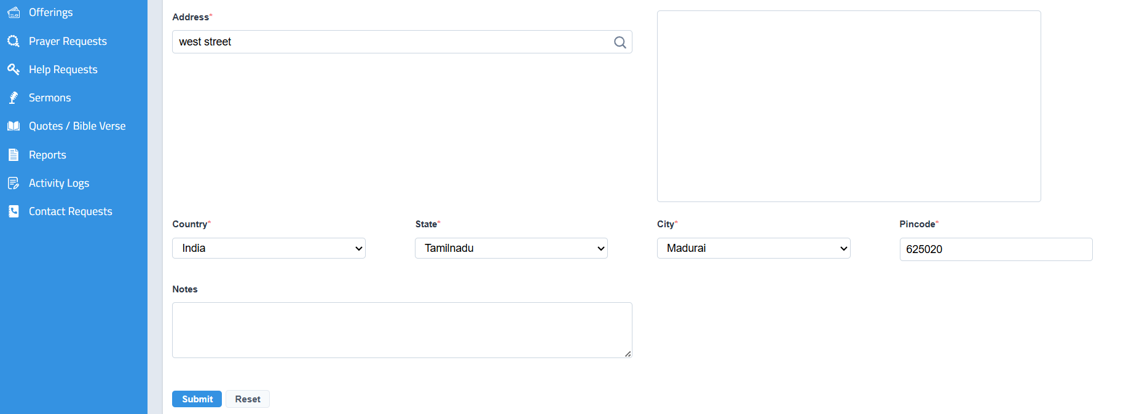

Deactivate Staff
- Click Deactivate.
- A confirmation message will appear asking whether you want to change the member’s status.
- Click OK.
- The member will be deactivated successfully.
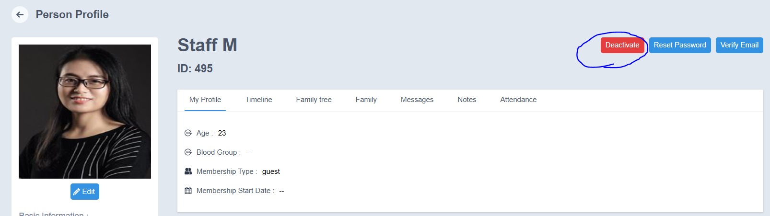
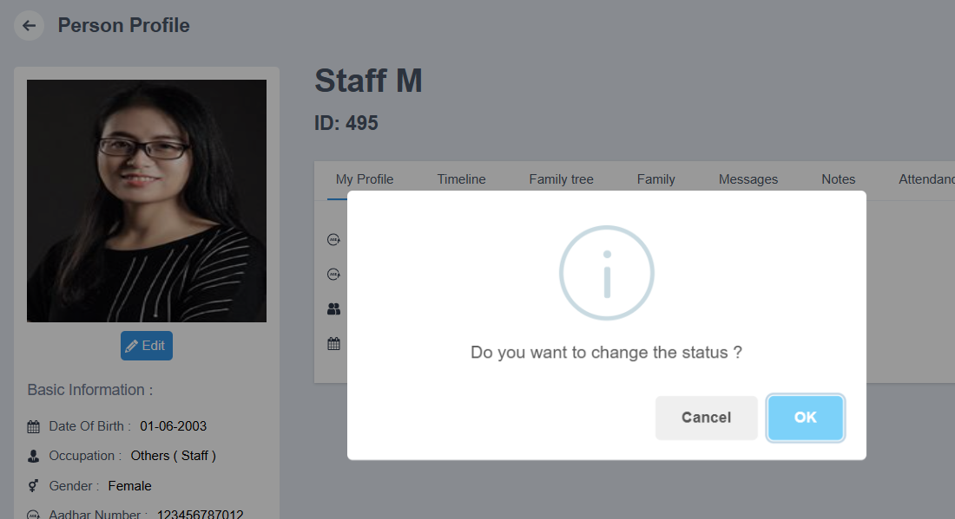

Reset Password
- Click Reset password
- A confirmation message will appear asking whether you want to reset the password.
- Click OK
- The password will be reset successfully.

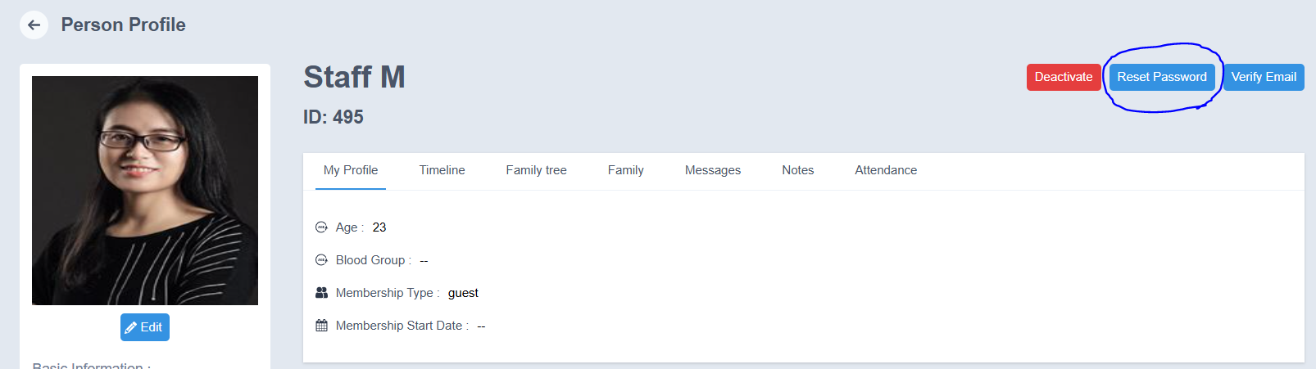
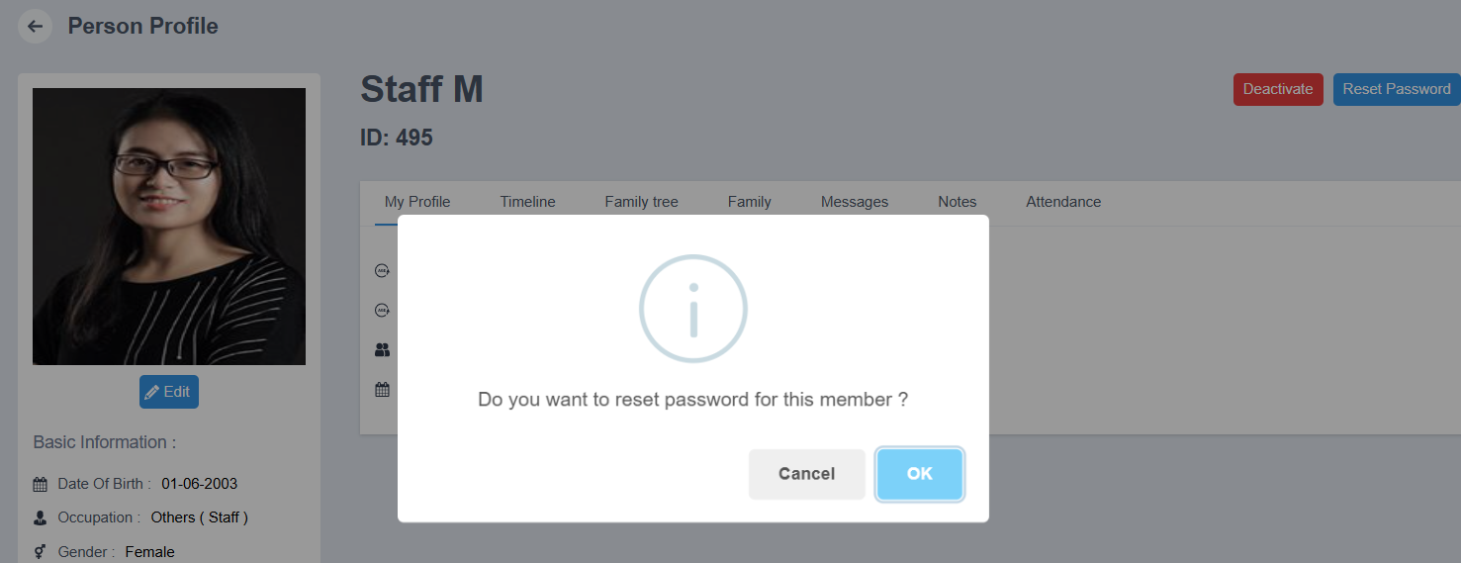

Verify Email
- Click Verify Email.
- A verification email will be sent to the member’s registered email address.
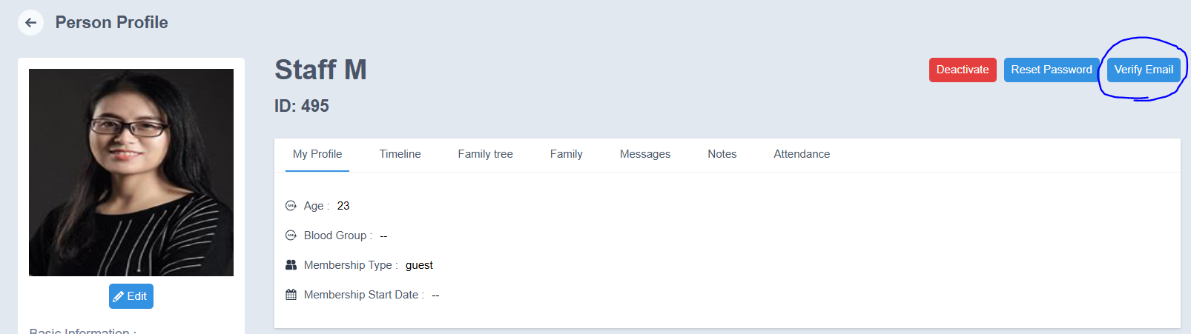

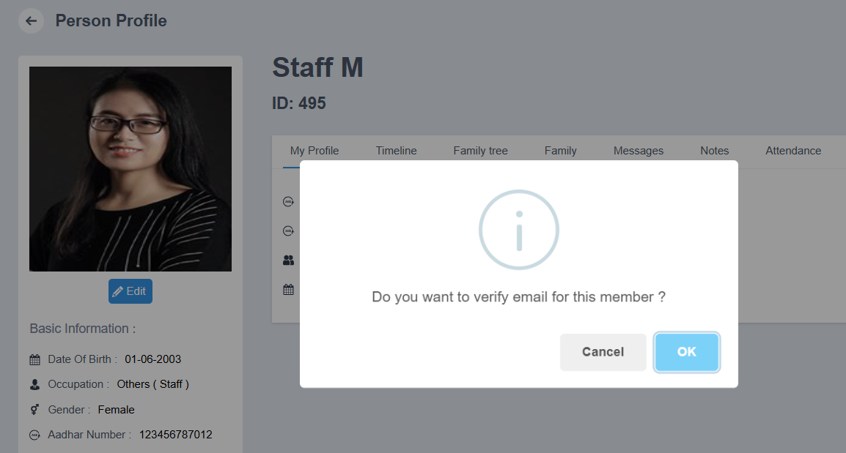
Outcome
- The new staff member will be added successfully to the portal.
- The staff record will appear in the Staff list.
Notes
- Ensure all mandatory fields are filled before submission.
- Verify details such as contact information and role for accuracy.

